1.What are the two values of the Boolean data type? How do you write them?  
Ans. True and False.

2. What are the three different types of Boolean operators?  
Ans. AND, OR , NOT.

3. Make a list of each Boolean operator's truth tables (i.e. every possible combination of Boolean values for the operator and what it evaluate ).  
Ans.  
 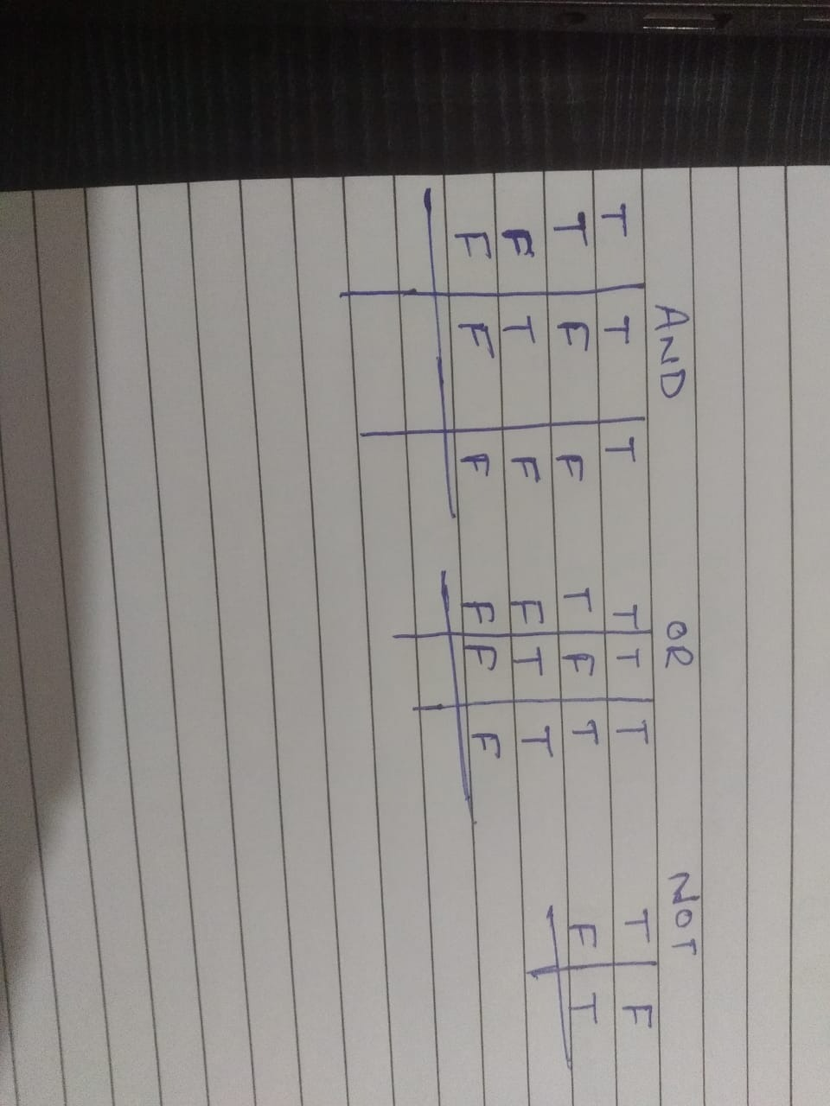

4. What are the values of the following expressions?

(5 > 4) and (3 == 5)

not (5 > 4)

(5 > 4) or (3 == 5)

not ((5 > 4) or (3 == 5))

(True and True) and (True == False)

(not False) or (not True)

Ans. (5 > 4) and (3 == 5) = False  
not (5 > 4) = False  
(5 > 4) or (3 == 5) = True  
not ((5 > 4) or (3 == 5)) = False  
(True and True) and (True == False) = False  
(not False) or (not True) = True

5. What are the six comparison operators?  
Ans. Equal to ==  
Not equal to !=  
Greater than >  
Lesser than <  
Greater equal >=  
Lesser equa <=

6. How do you tell the difference between the equal to and assignment operators? Describe a condition and when you would use one.  
Ans. == is the equal to operator used to compare 2 values and = is used to in variable while storing some data.

7. Identify the three blocks in this code:

spam = 0

if spam == 10:

print('eggs')

if spam > 5:

print('bacon')

else:

print('ham')

print('spam')

print('spam')

**Ans.** print('eggs')  
if spam > 5:  
print('bacon')  
else:  
 print('ham')  
 print('spam')

8. Write code that prints Hello if 1 is stored in spam, prints Howdy if 2 is stored in spam, and prints Greetings! if anything else is stored in spam.  
Ans. if spam == 1:

print('hello')

elif spam == 2:

print('howdy')

else:

print('Greetings!')

9.If your programme is stuck in an endless loop, what keys you’ll press?  
Ans. Ctrl+f2

10. How can you tell the difference between break and continue?  
Ans. Break is used to stop the execution after a loop and continue will move the execution to the start of loop unless it reaches the largest value.

11. In a for loop, what is the difference between range (10), range (0, 10), and range (0, 10, 1)?  
Ans. Range (10) from 0 up to 10, range (0,10) will call the loop from 0 to 10 and range (0,10,1) will call the loop from 0 to 10 and increase the variable by 1 on every iteration.

12. Write a short program that prints the numbers 1 to 10 using a for loop. Then write an equivalent program that prints the numbers 1 to 10 using a while loop.  
Ans. For loop-   
for i in range(1,11):  
print(i)

While loop-   
i=1  
while i<11:  
 print(i)  
 i = i+1

13. If you had a function named bacon() inside a module named spam, how would you call it after importing spam?  
Ans. spam.bacon()